

**ELIM CHRISTIAN CENTRE**

Park Road, Southampton SO15 3DE

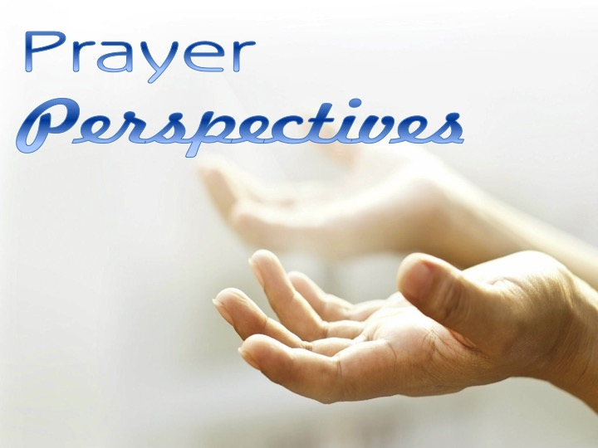

3/7/16

Prayer Perspectives 1-Introduction

Pastor Brian Wallis

10/7/16

Prayer Perspectives 2-Pray On All Occasions

David Oppong

17/7/16

Prayer Perspectives 3-Pray In The Spirit

Pastor Brian Wallis

24/7/16

Prayer Perspectives 4-Different Kinds Of Prayer

Jeanne Linn & Sandy Murray-McIndoe

31/7/16

Prayer Perspectives 5-Faith In Prayer

John Owusu-Afram